***Entach***

A Revolution in location tracking

I’ll start at the beginning. Entach came about because of a persistent problem in FIRST Tech Challenge (a robotics league). FTC tries to mix sports, engineering, and teamwork all into one competition. To satisfy the sports part, the game masters make a new game each year. There are some consistence factors though. The match is always two minutes. In the first thirty seconds, the robots are completely unmanned and run a program written by the creators of the robot. In the other minute thirty, the robots are driver controlled via a PS3 controller. Although the method of scoring points changes each year, there is always the problem of *getting* to the scoring area. In aut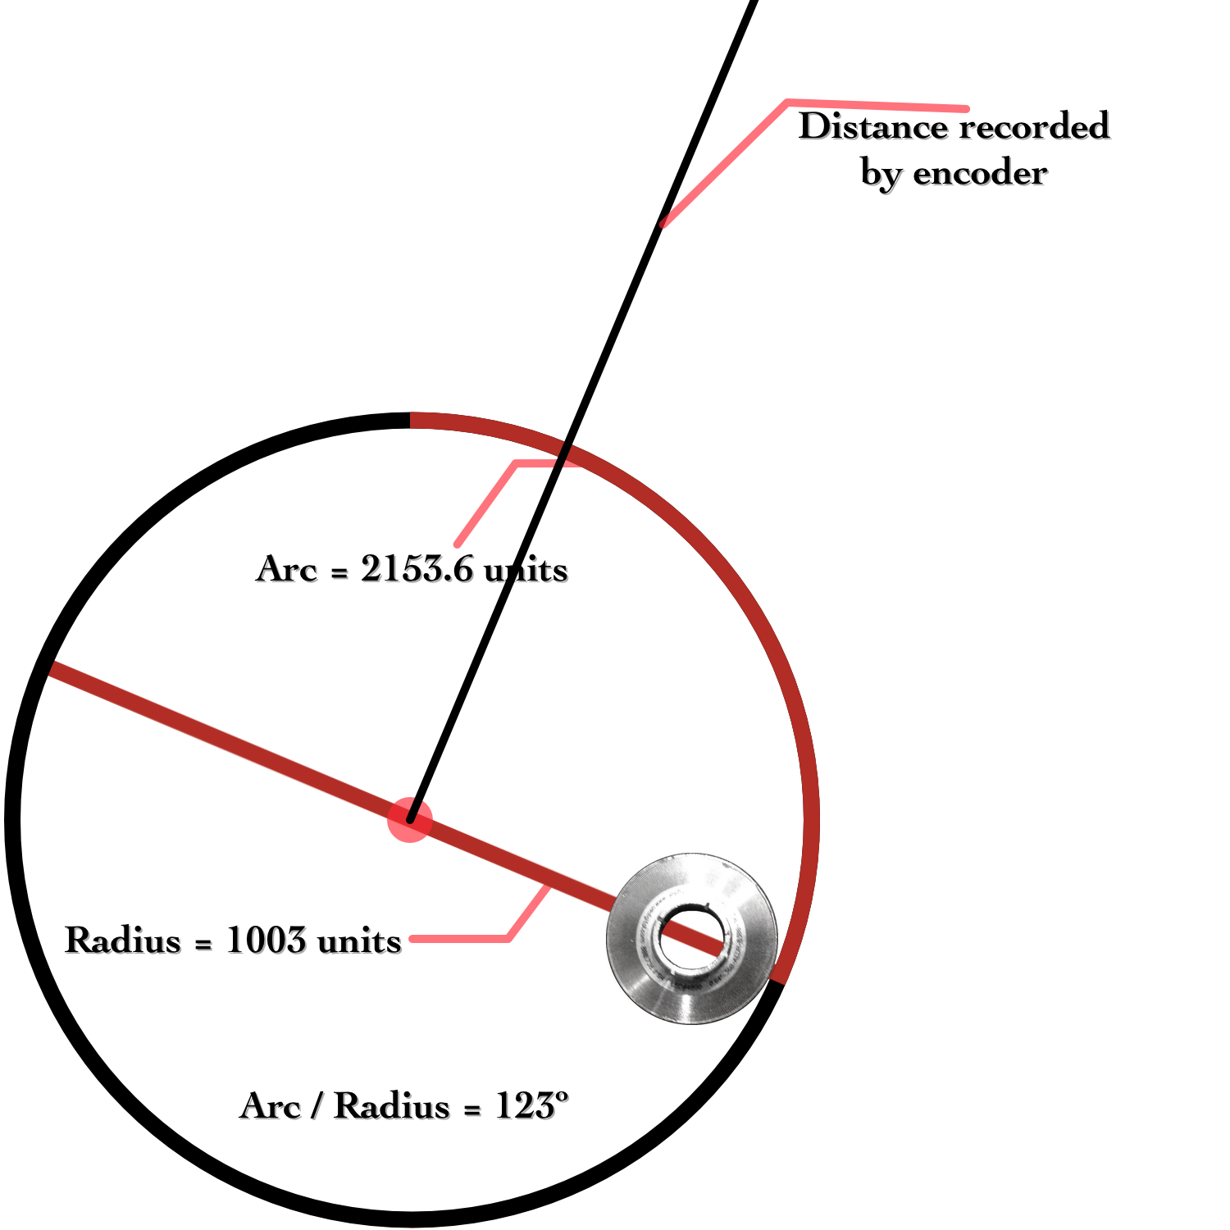onomous it’s a lot harder. Humans have a complex sense of space which is very difficult to replicate in a robot. Despite this many teams have tried to replicate this in a variety of ways.

One way is by use of sensors. FTC offers a somewhat limited but usable selection of sensors (for financial equality reasons) from HiTechnic and LEGO. A portion of their selection consists of the accelerometer (senses acceleration), the light sensor (detects light levels), and the ultrasonic sensor (can sense distance like bat or submarine). Although these sensors sound cool, it turns out all of these methods have about a 10% - 50% success ratio. Why? The sensors and time are not reliable enough to get a ratio of 100%. Here’s a run down of why:

Above is a chart of acceleration as recorded by our accelerometer. As you can see, the amount of noise HiTechnic’s accelerometer produces renders it almost useless.

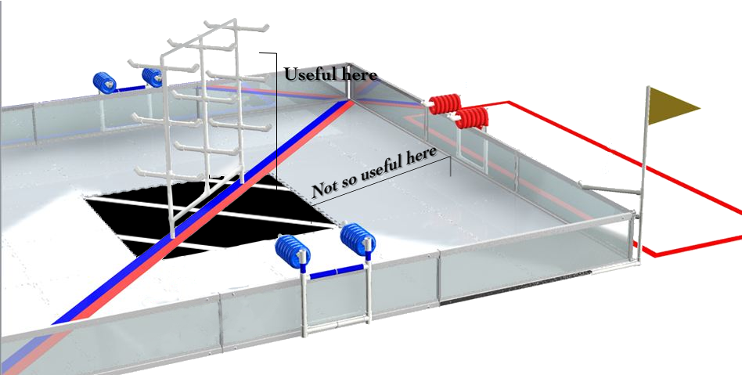

As for the light sensor, it’s terrific for sensing if the robot is passing a peg or for sensing white on black lines, but less than helpful at getting to the pegs or lines in the first place.

What we need is something *WAY* more precise than these sensors, a leapfrog sensor to put us in the 100% success rate range. We needed a sensor that could do three things:

* + 1. Have minimal noise (unlike the accelerometer)
    2. Sense if the robot is actually moving (not stuck on something like with time)
    3. and most importantly, track location in 2D space

The solution to the first one is use an encoder. Encoders have the ability to track distance as it moves along a line. What we found with the encoder is it gives no noise! It doesn’t miss an single millimeter. Problem number 1 solved.Normally, encoders attach onto motor axles and record as the motor spins, but this doesn’t solve problem number 2. So, we removed the encoder from the motor entirely!

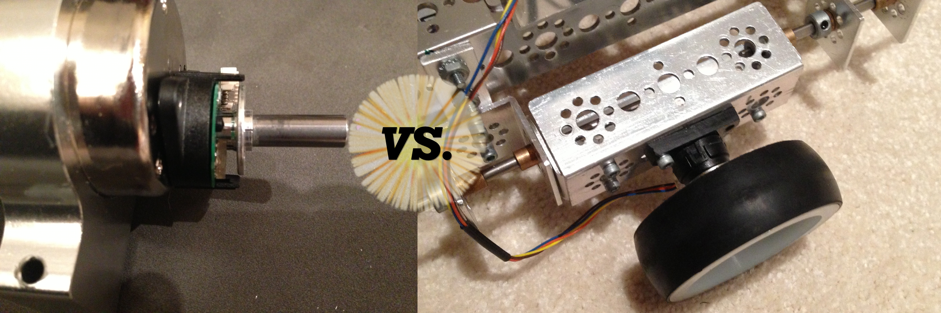

As for number 3, we had breakthrough: when the robot is turning an arc on its axis, the encoder records the length of arc, and the simple formula:

*Arc / Radius = Angle*

tells the software what its current angle is. When the robot is moving forward, the encoder records the usual linear distance. Combine angle and distance with sine and cosine and the result is an x, y coordinate. Problem number 3 solved.



The sensor we created has been dubbed Entach (Encoder Detached). It could now do the three task no FTC sensor could even hope to accomplish! Consistently we’ve been able to get to a destination with an error of 0 – 5 centimeters! No matter how near or far the destination is, it will always land on target!